ITRW 324 Research Project

ITRW324 Research Project Submitted for the degree Baccalaureus Scientiae in information technology at the North-West University

Student number:

25948083

**Table of contents (Heading 0)**

1.1 Introduction 1

1.2 Concepts for discussion 1

1.2.1 Architectural patterns 1

1.2.2 Code refactoring 1

1.2.3 Advanced design principles 1

1.2.4 Unit testing 1

1.3 Conclusion 1

List of Tables (Heading 0)

Table 1‑1: Unit Testing Table 1: https://bit.ly/2JLOZx7 3

List of Figures (Heading 0)

Figure 1‑1: Figure for unit testing https://bit.ly/2OdPovU 1

Figure 1‑2: Figure for unit testing https://bit.ly/2mHd1k1 2

Assignment 1

## Introduction

## Concepts for discussion

### Architectural patterns

### Code refactoring

### Advanced design principles

### Unit testing

## Conclusion

# Heading 1 won’t print. Don’t delete – doing so will lead to incorrect numbering.

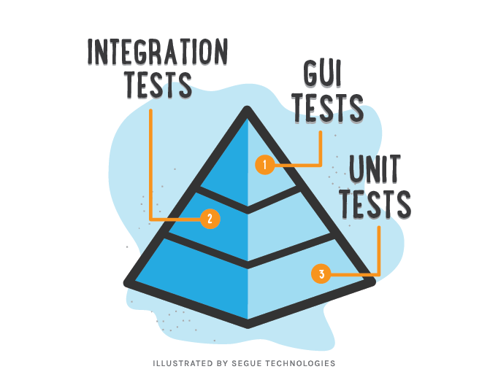

Figure 1‑1: Figure for unit testing https://bit.ly/2OdPovU

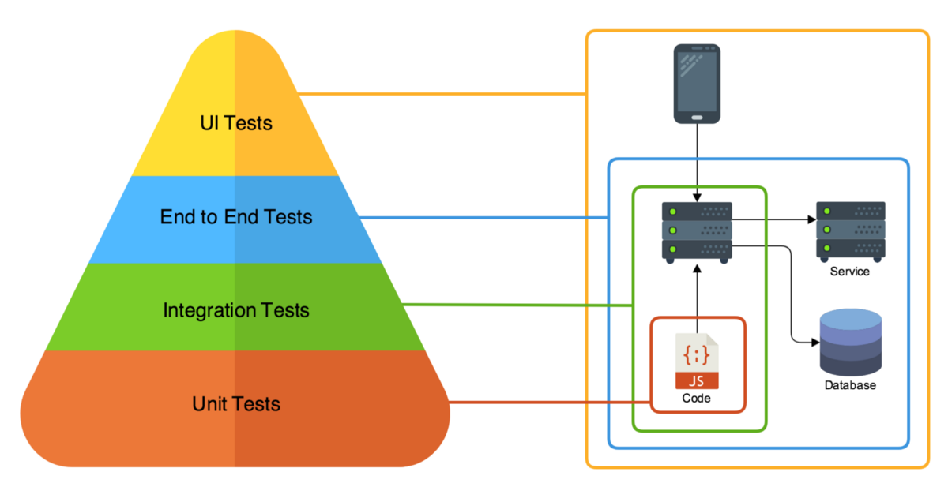

Figure 1‑2: Figure for unit testing https://bit.ly/2mHd1k1

Table 1‑1: Unit Testing Table 1: https://bit.ly/2JLOZx7

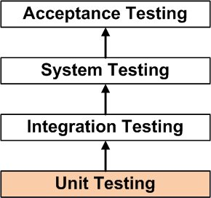

Referenches(TOC_Heading)

Bibliography Bibliography Bibliography Bibliography Bibliography Bibliography Bibliography Bibliography

Bibliography Bibliography Bibliography Bibliography Bibliography Bibliography Bibliography Bibliography

Bibliography Bibliography Bibliography Bibliography

Annexures (TOC_Heading)

Last Updated: 30 April 2018